15.Aim :To design TM using simulator to accept the input string anbn

INPUT:

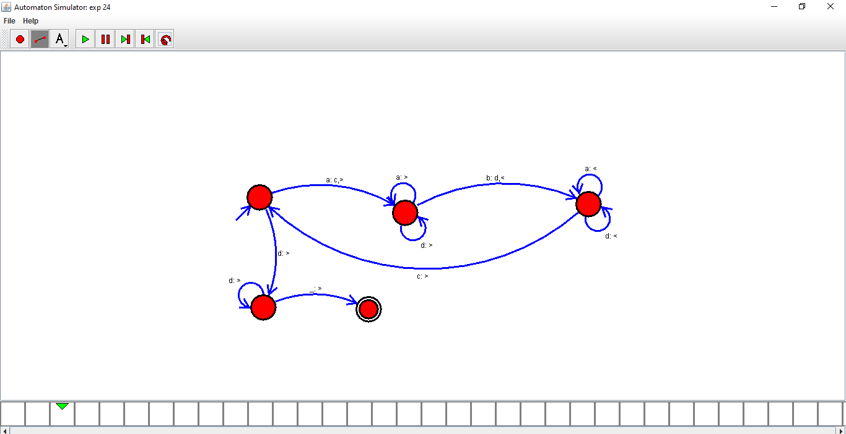

OUTPUT:

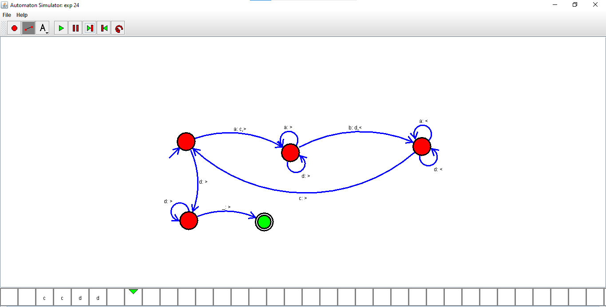

RESULTS:

Thus designed TM using simulator to accept the input string anbn